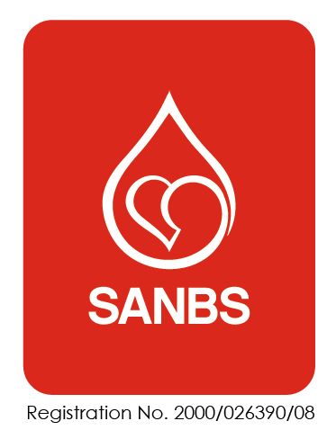
INFORMATION RELATED TO BLOOD SAMPLES INTENDED FOR TESTING WITHIN THE TISSUE IMMUNOLOGY LABORATORY AT THE SOUTH AFRICAN NATIONAL BLOOD SERVICE

Sample labelling:
- All samples must be labelled with two forms of identification.
- Name and surname is mandatory.
- The second form of ID could include:
- ID number
- Date of birth
- Hospital number
- Requisition number
- Please know that if samples are not correctly labelled, it may result in the testing not being performed.
- Please also know that the Tissue Immunology Request Form (FRM-SLS-091) must be completed in full. Details such as diagnosis/ICD 10 codes, patient and donor relations, and patient sensitization history is mandatory to ensure accurate results.
Sample transportation and packaging:
All samples must be transported at room temperature. There are two exceptions though:
- Samples being sent from distant locations, taking longer than 24 hours to reach the laboratory, must be kept cool (refrigerated temperature, approximately 2-10 degrees Celsius). Please ensure that samples do not freeze.
- ACD (yellow top) samples from donors intended for CDC crossmatching MUST stay at room temperature at all times.
All samples must be packaged in such a way that to ensure the integrity of the samples and the safety of the courier.
- Blood samples must be placed inside a plastic sleeve, to contain any potential spills. If unavailable, plastic envelopes can be obtained from the Tissue Immunology laboratory.
- Thereafter please place the plastic sleeve/envelope into a suitable container to protect the blood samples.
Sensitizing events:
HLA antibody results may be affected by sensitizing events such as pregnancies, blood transfusions and transplants.

In the event of a patient undergoing any potential sensitizing events, please only draw blood samples 14 days later so that the antibody testing will accurately reflect the patient’s updated immune status.

If you have any questions or queries related to the above, please contact the Tissue Immunology laboratories on: 011 761-9227/8 in Constantia Kloof or 031 719-6615/9 in Pinetown.

Revision Summary

VERSION NUMBER | REVISION DETAILS
0 | New document.

